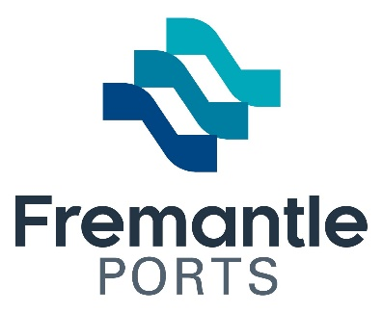
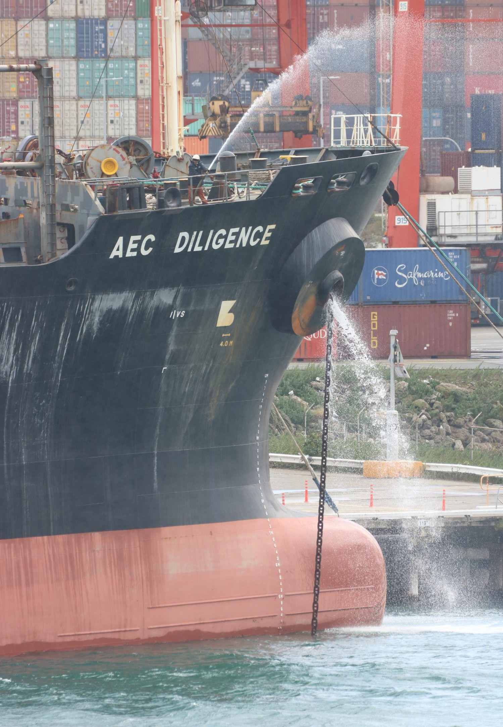

Community Investment
Program

Acquittal Form

Introduction

This acquittal and evaluation form applies to any community investment grant received from Fremantle Ports. This will help us understand how effective this community investment has been for us and for your organisation.

This acquittal is due 30 days following the event/activity or completion of the program or project. Failure to return the acquittal by the due date may result in ineligibility for future applications and in some cases a request for return of the community investment paid amount.

Organisation name:
Postal address:
Organisation’s contact details:
Contact person:
Contact person’s position:
Contact person’s contact details:

Name of funded program or event:
Amount awarded by Fremantle Ports | $
Event date/s if applicable

Participant and Audience Success

State the total number of people that attended your event ___________.
If no event was held, state the estimated number of people impacted by your initiative.
From this total number, please estimate the numbers of people in each category.

 | Children  <12 yrs. | Young people >12  to <24 yrs. | Adults >24 yrs. | Aboriginal | Catchment area
Participants
Attendees
Volunteers

Marketing and Promotion

Please attach copies of all promotional materials which illustrate how you acknowledged Fremantle Ports such as media articles, social media, flyers, posters and invitations.
Please answer the following questions on how successful your event or program was (use dot points if you wish, however, full information is sought).

Attach another sheet of paper if more room is required.

- How was your event, program or activity promoted?

- What were the community benefits?

- What were the stand-out achievements?

- Were there any problems or issues identified and how were these dealt with, and how will would you address these in the future?

- Is your organisation likely to run the event, program, or activity again? If not, why not?

Expenditure

Fremantle Ports wishes to understand how the community investment grant was spent. Please outline how money was used for your initiative.

Attach another sheet of paper if more room is required.

Purchases | Amount
Total Expenditure | $

Conclusion

How would you rate overall the worth of Fremantle Ports’ assistance to you? Please select one of the following.

Very helpful | Helpful | Slightly helpful | Not helpful

If you have any additional feedback about our community investment process, our role or anything else you consider important about your initiative, please share this with us.

Attach another sheet of paper if more room is required.

Agreement

“I/We certify that this is a true and accurate record of the evaluation of funding provided by the Fremantle Ports Community Investment Program.”

Name:

Position:

Signature:

Witness:

Signature:

Organisation:

Please send your completed report to:

Government & Public Relations Fremantle Ports
PO BOX 95
Fremantle WA 6959

Or email to: mail@fremantleports.com.au

