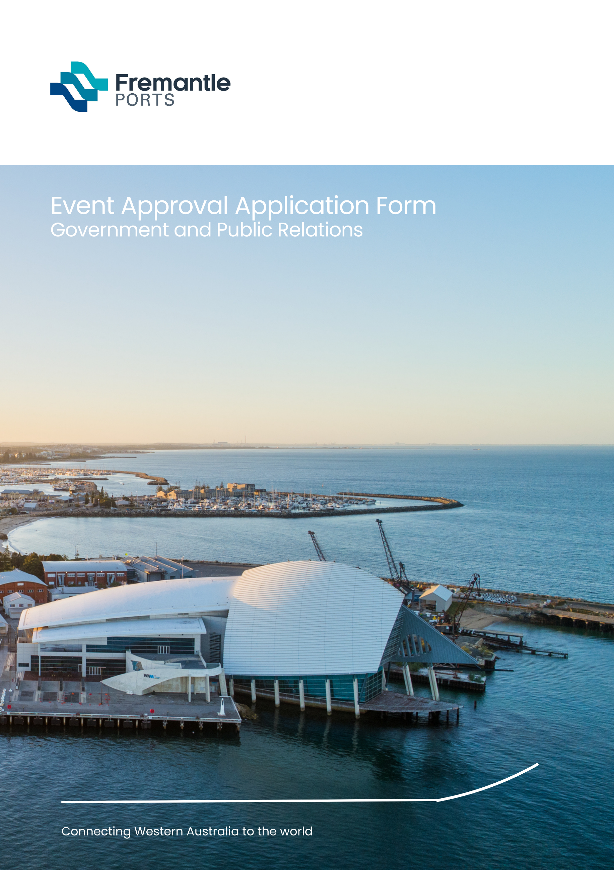

Document Title
Sub Title

Thank you for your interest in hosting an event at Fremantle Ports. We appreciate your interest and your time spent completing this form. Here are tips steps before you get started:

1. This form is an application only. Before submitting your application form, read the Fremantle Ports Guidelines for Event Approval (available online) and contact Government and Public Relations by sending an email to: governmentpublicrelations@fremantleports.com.au outlining your concept/proposal (not all concepts/proposals will be suitable).
2. Applications must be received 60 working days prior to the requested date of event.
This helps us ensure the event meets our safety requirements and does not clash with planned maintenance or development work or other events and has approval to proceed in time so you can promote your event successfully.
3. Applications must be completed in full including all pertinent attachments prior to submission.
4. Incomplete applications cannot be accepted.
5. Where additional information is required, this should be provided as attachments to your email.
6. You must include your Certificate of Currency (insurance) and signed indemnity to your application (indemnity form is included in this form and available online from our website).
You will require a minimum of $10 million dollars insurance (insurance at a higher level may be required depending on the event).
7. Application assessment fees may apply.

Applicant details
Name of organisation:
Primary contact:
Position held in organisation:
Organisation address:
Contact phone number:
Contact mobile number:
Primary contact email address:
Website:
Facebook:
Instagram:

Compulsory details - all applications
Please attach any relevant documentation to your application
COMPULSORY DETAILS | DETAILS | OFFICE USE ONLY
Background and history of event, if any. | Attach to application
Is your organisation status not for profit?
Details of any event sponsors or beneficiaries.
Event Management Plan (EMP) including program of activities. As well as Fremantle Ports Guidelines for Event Approval, events must comply with WA Department of Health policies:
Guidelines for concerts, events and organised gatherings. Tools are available to help you develop your EMP within this document.
Traffic Management Plan (TMP) (including road closure or restriction to vehicular traffic both within and around Fremantle Ports’ boundaries and parking arrangements). A template is available in Guidelines for concerts, events and organised gatherings
(WA Department of Health). Tools are available to help you develop your TMP within this document.
Risk Management Plan (RMP) including Safety and Environment and Communication.
Download the Fremantle Ports Risk Assessment Template.
Tools are also available to help you develop your RMP at Guidelines for concerts, events and organised gatherings (WA Department of Health).

Compulsory additional details for water-based events.
Before you complete this section, please note:
- The Port Authorities Act 1999 and Port Authorities Regulations 2001 apply to all events approved by Fremantle Ports.
- Water-based events are approved by the Harbour Master and the decision is final.
- The Harbour Master also has the power to suspend or cancel activities at any time for any reason.
- The organisers must comply with all directions or orders issued by or on behalf of the Harbour Master.
Please see Fremantle Ports Event Approval Guidelines for further information on what is required.
COMPULSORY DETAILS | DETAILS | OFFICE USE ONLY
(please attach any relevant documentation to your application - suggested inclusions below) | Attach to application
Drawings showing event course | Attach to application
Approval from Department of Transport Marine Division to control and escort all private craft through the Fremantle Inner Harbour (proponent’s responsibility) | Attach to application
If wharf space or land area is also required, please include details in this application | Attach to application
Approval from any other relevant organisations including Water Police, City of Fremantle, etc. | Attach to application

Compulsory additional details - land-based events
Before you complete this section, please note:
- Land-based events are approved by the Manager - Government and Public Relations, and their decision is final.

- Fremantle Ports can suspend or cancel activities at any time for any reason.

- Organisers must comply with all conditions.

- Applications that involve place activation of Victoria Quay will be well regarded.

- Please see Fremantle Ports Event Approval Guidelines for further information on what is required.
COMPULSORY DETAILS | DETAILS | OFFICE USE ONLY
Primary purpose of event | Attach to application
Map showing event footprint | Attach to application
Site plan detailing type of equipment and infrastructure that you intend installing at the event. Please include site map. | Attach to application
Compulsory Event Management Plan to include whether you are charging entry fees, entertainment, how you will control noise, lighting, food/drink, erection of signage, pyrotechnics, etc. | Attach to application
Declaration by applicant
I acknowledge that I have read the Fremantle Ports Guidelines for Event Approval and that all information provided in the application is complete, true and correct and contained therein.
Signature of authorised person from organisation
Signature of witness
Send completed applications by email to: governmentpublicrelations@fremantleports.com.au
Note: indemnity form begins overleaf.
